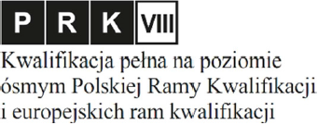
Appendix no. 1.1 to Rector's Order no. 129/2020

ISSUED IN THE REPUBLIC OF POLAND
MEDICAL UNIVERSITY
OF BIALYSTOK
DOCTOR DIPLOMA
………………………….
(forename and surname)
born on ……………………. . in ………………..
on the basis of the presented/awarded* doctoral dissertation ……………………
…………………………………………………………………………………….……
……………….…………………………………………………………………………
obtained the academic degree
DOCTOR
of Medical and Health Sciences
in the discipline of medical/pharmacology and pharmacy/health sciences*

granted by the resolution of the Senate of the Medical University of Bialystok
of ............................... .
Advisor: …………………………………….
Second Advisor/Auxiliary Advisor* …………………………………….
Reviewers: …………………………………….
…………………………………….
…………………………………….
mp.

Białystok, ......................... …./…./….. .............................................................
diploma no. (name stamp and signature of the Rector
or person authorized by him)
*leave appropriate

