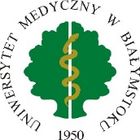
Letter of intent for a student / PhD student /
graduate / post-doc of Medical University of Bialystok
participating in the Erasmus+ Programme traineeship

- Details of the receiving institution
Legal name of the receiving institution
Address
Country
Erasmus code (if applicable)
Type of organisation
Size of organisation (approx. number of employees)

- Details of the person responsible for the participant during the traineeship period
Name and surname
Position
Address
Postal code, city
Country
E-mail

- Details of the student/PhD student/graduate/post-doc
Name and surname
Year and field of study
Student ID number

- Short description of the traineeship programme

We, …………………………………………………………………. (name of the receiving institution) hereby confirm our willingness to host the above mentioned student / PhD student/graduate/post-doc of Medical University of Bialystok for a traineeship placement from ………………….. to ……………………. within the framework of Erasmus+ Programme.

The receiving institution binds itself to complete the traineeship programme according to the plan agreed upon by all three parties in the Learning Agreement for Traineeship form.

Date | Signature of the authorized person | Stamp of the receiving Institution

Delete as appropriate
Delete as appropriate
Delete as appropriate

