appendix to the Order of the Rector of the MUB no. 21/2021 dated 18.03.2021

Linking a PBN account to an ORCID and POL-on account

- Go to the website https://pbn.nauka.gov.pl/core/#/home

- a) If you already have a PNB account, click Zaloguj in the upper right corner, log in to the PBN and follow the instructions below, starting with step 6.
  - If you do not remember the password or when trying to create a new account you receive a notice that the account already exists, click Zapomniałeś hasła? Enter the email address to which you will receive a link to change your password. Enter the new password, approve it, log in to the PBN and continue to follow the instructions below, starting from step 6.

  - If you do not have the PBN account, click Zaloguj in the upper right corner, and then click Zarejestruj się.
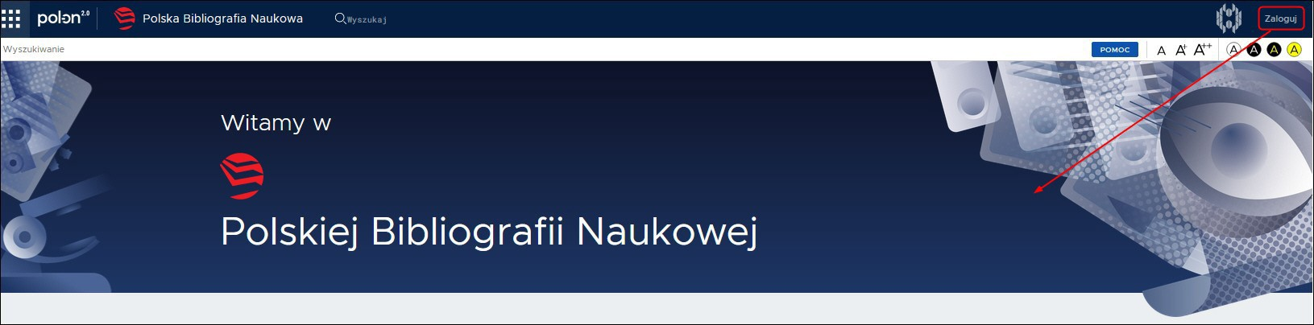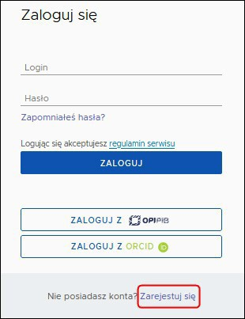

- Fill in the data in the registration form, accept the terms of service and click ZAREJESTRUJ.

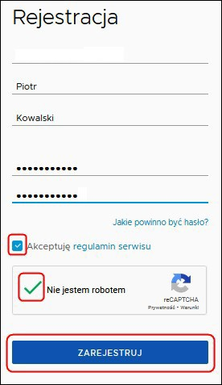

- In the message received to the provided e-mail address, confirm the registration by clicking PRZEJDŹ DO SERWISU.
- 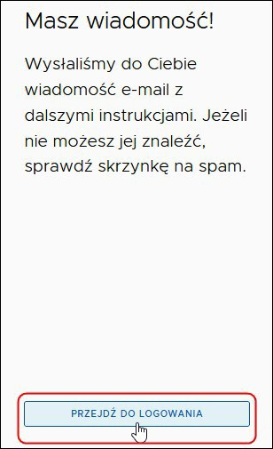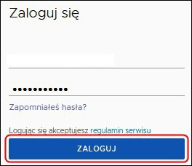Click PRZEJDŹ DO LOGOWANIA, then log in to the PBN.
- To link the PBN account to your ORCID account, click the ORCID button.
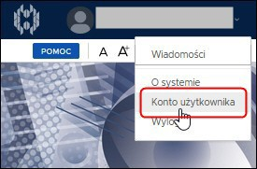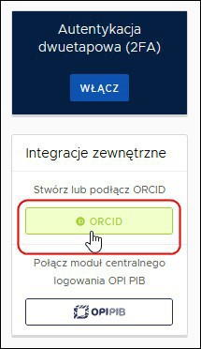METHOD 1. Immediately after logging into the PBN METHOD 2. From your PBN account (when you first log in)
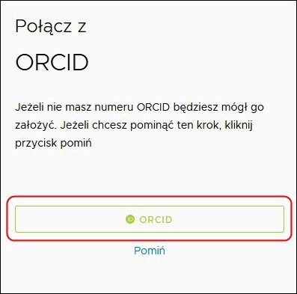

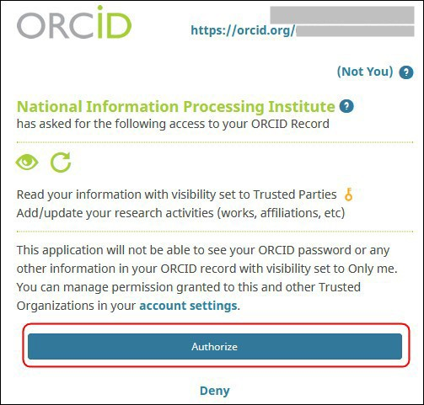
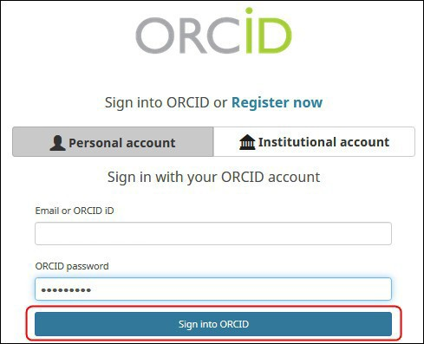
- Log in to the ORCID, then agree to the access to data collected in the ORCID by clicking Authorize.

- 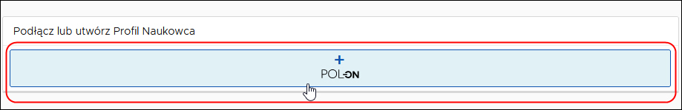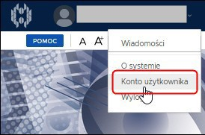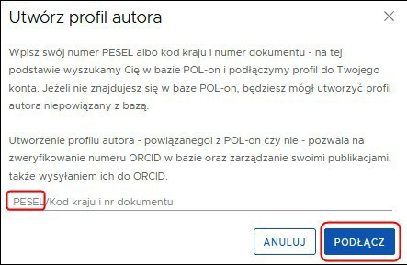To link your PBN account to your POL-on account, enter the PESEL number [Personal Identification Number] and click ZAREJESTRUJ/PODŁĄCZ

METHOD 1. Immediately after logging into the PBN METHOD 2. From your PBN account (when you first log in)

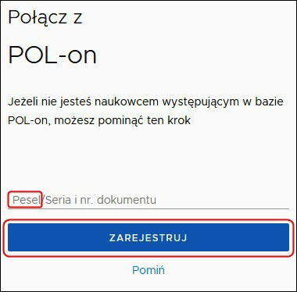

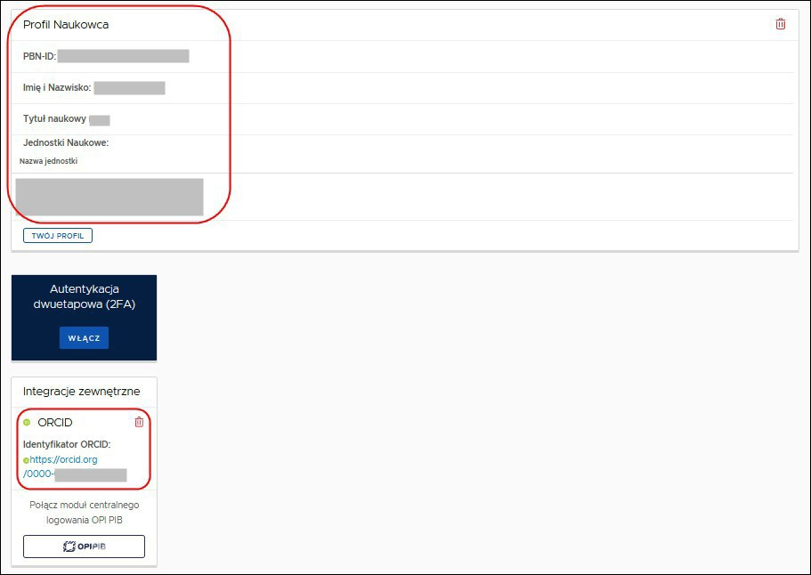
- PBN account view when properly linked to ORCID and POL‐on.
If you have problems linking your PBN account to ORCID or POL-on, please contact:
− Helpdesk PBN https://lil-helpdesk.opi.org.pl/#/login

